BOOTSTRAP QUICKSTART GUIDE

1. **Open your browser and go to** <https://v4-alpha.getbootstrap.com/>**. Once at the site, copy the code in the blue circle.**

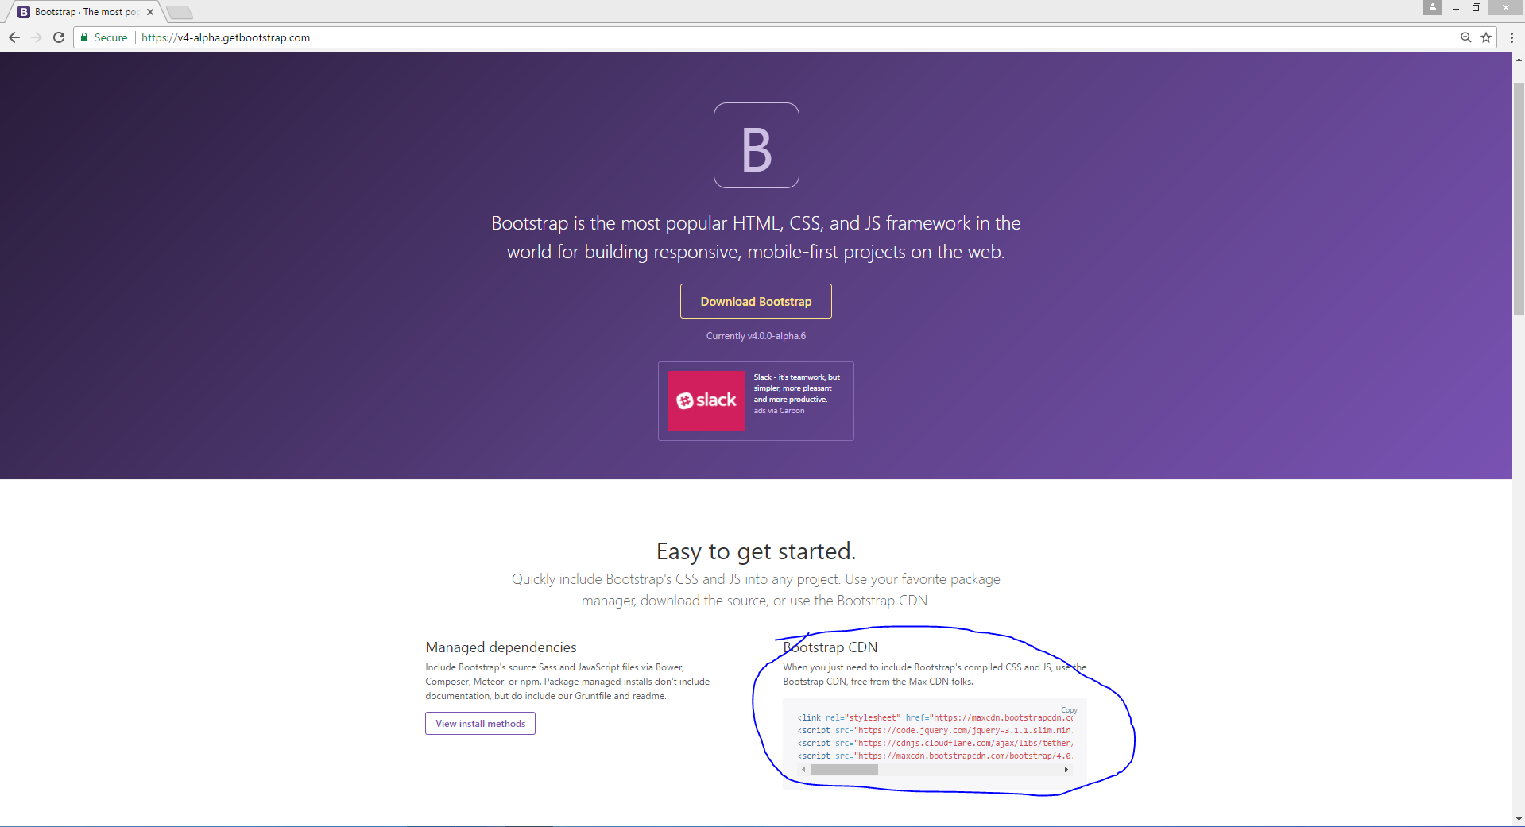

1. **Open up your text editor and paste the javascript lines just above the </body> tag at the end of your code. Paste the <link> line from bootstrap with the rest of your link references.**

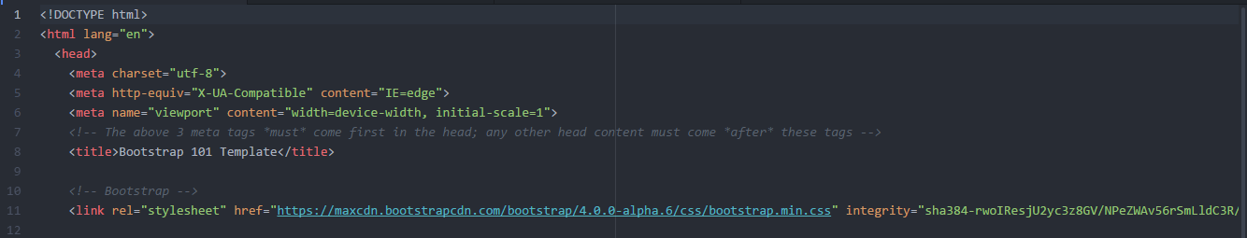

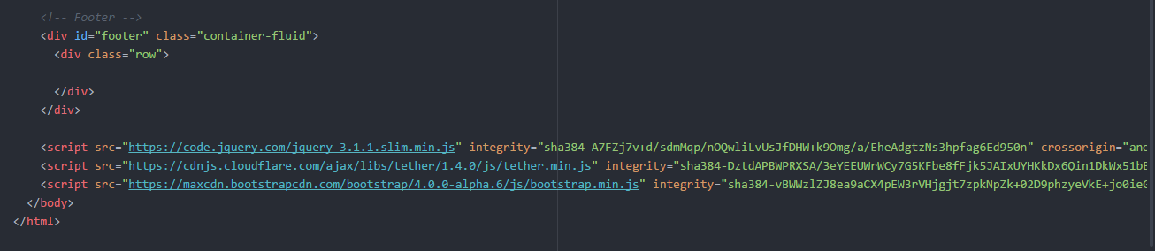

1. **To use the features of Bootstrap, go to the bootstrap homepage and click on documentation in the toolbar. Then click on components in the sidebar in the blue circle.**

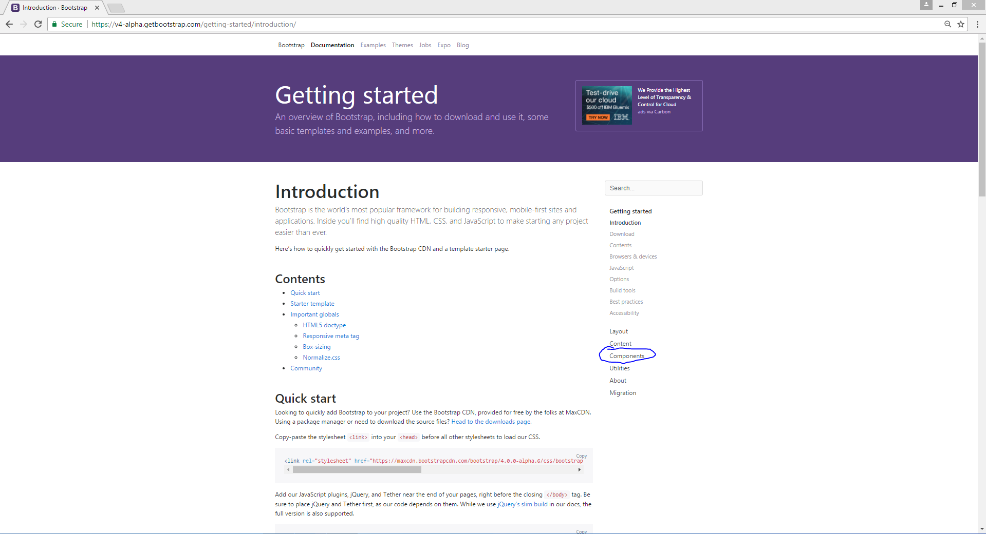

1. **Click on something you want, like “Buttons”. Then look at the examples, and find one you like. There will be example code that matches the example that you like. Copy this code and paste it into your own code. You will now see this button wherever you placed it when you run your code.**

